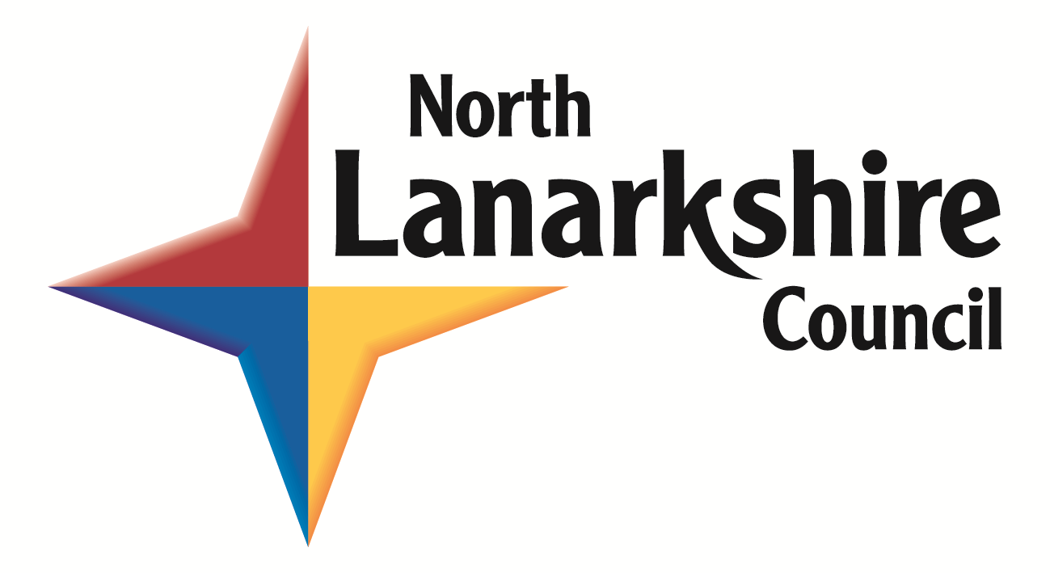

Policy on the Public use of ICT Resources and the Internet in North Lanarkshire Libraries

General Statement

North Lanarkshire Council provides public access to Information & Communication Technology (ICT) and the Internet in libraries, in keeping with its role as a source of information, lifelong learning, health & wellbeing and cultural enrichment for the community.

This Policy on the Public Use of ICT and Internet is also applicable to users who access the Internet using their own laptop or other device through North Lanarkshire Council’s Wi-Fi connection. Customers using the Wi-Fi connection must not provide their password to any other person. Wi-Fi connection is provided by a third party (BT) and is subject to T&Cs at the point of initial sign on.

Customers will only be provided with access to ICT and the Internet, via a public access computer, upon production of the required personal identification or in the case of library services a valid North Lanarkshire library membership card. North Lanarkshire Council reserves the right to amend identification or membership requirements.

If a customer is a debtor of North Lanarkshire Council access to ICT resources and the Internet will only be provided once a minimum payment has been made towards the debt prior to access.

North Lanarkshire Council has no control over any information accessed via the Internet and cannot be held responsible for the content or quality of the information retrieved from the Internet.

Transmission of or display of any material in violation of any law is prohibited. This includes but is not limited to copyright material, threatening, racist, obscene or other discriminatory material, pornographic material, or material protected by trade secret. North Lanarkshire Council will be the sole judge of what is deemed to fall within these prohibited categories.

Customers should be aware that use of the Internet will be monitored and that records of websites accessed may be inspected or passed on to third parties or the Police or other lawful authorities to prevent or detect crime, or to protect public funds in other ways, as permitted by law. These third parties include government departments, local authorities & copyright agencies.

E-commerce transactions can be carried out including online shopping. Please note, however, that North Lanarkshire Council accepts no liability or responsibility in regard to these transactions, and they are carried out at the user’s own risk. Customers should take all possible steps to protect their personal information.

North Lanarkshire Council has no responsibility for any loss, damage or injury as a result of using ICT resources.

Use of North Lanarkshire Council Internet Provider address for commercial purposes is prohibited.

Adult customers (16 years and over) are required to sign an Internet User Agreement form which indicates they agree to abide by the terms of this policy as amended from time to time. A full copy of the current policy will be displayed for reference purposes. It is the responsibility of the customer to check the terms of the current policy prior to use of the service. Junior customers (under 16 years) must obtain, prior to the first use only, the signature of a parent/guardian who will be responsible for any restriction and supervision of the child’s access to the Internet. It is the responsibility of the parent/guardian to ensure they have read the terms of the current policy prior to signing.

Wifi

Wi-Fi connection is available to the public free of charge in some North Lanarkshire Council facilities. North Lanarkshire Council cannot guarantee that every IT devices connected via our wireless service will operate, given the many and varied IT products that are available on the market.

North Lanarkshire Council staff will provide basic assistance where possible but it is the customer’s responsibility to make any changes on their own equipment to make it compatible. User-logins may not be provided in future if customers breach the Policy on the Public Use of ICT Resources and the Internet while using their own equipment.

Services Available

The following services are available subject to the terms of this policy:

Access to the Internet
Electronic Mail
Printing (subject to the displayed charge)
Chat
Downloading of Material (subject to copyright law)
Wi-Fi (in selected facilities only)

Unacceptable Use

Customers must agree not to:-

- Use the network to make unauthorised entry to other computers, information or communication services or resources.

- Distribute unsolicited advertising.

- Invade the privacy of others.

- Make any attempt to damage computer equipment or software.

- Access or display any information which could reasonably be construed as obscene, threatening, discriminatory or otherwise in breach of this policy.

- Engage in any activity that could be construed as harassment or defamation.

- Use the Internet for any fraudulent or other illegal activity including violating the copyright of others by e.g. downloading pirated copies of film or music; violating the terms of the Data Protection Act 2018 or other rights of third parties, or in a manner inconsistent with North Lanarkshire Council’s operation.

By signing the Internet User Agreement customers will be deemed to accept the whole terms of this policy. Unlawful activities or other activities which are deemed to be in breach of this policy will be dealt with in an appropriate manner by the relevant authorities. This could include but is not restricted to temporary or permanent restriction or suspension of use of ICT and Internet facilities, suspension of use of specific or all North Lanarkshire Council Ltd services, reporting unlawful activities to the Police and other lawful agencies, and taking legal action against offenders.

Security

Customers should be aware that the Internet is not a secure medium and that third parties may be able to obtain information regarding the customer’s activities. Where wireless connectivity is available the connection may be open and therefore not encrypted. Transmission of data packets may therefore be able to be seen by third parties or intercepted by them. Customers should ensure they take steps to protect their personal information whilst using the Internet, Wi-Fi and ICT resources. North Lanarkshire Council will not accept responsibility for any misuse or loss of a customer’s personal identification caused by their use of the Internet Wi-Fi or ICT resources. North Lanarkshire Council will monitor use of the Internet but will not reveal information on the use of specific Internet resources by members of the public except as required or permitted by law.

Use of Personal Equipment

The use of data capture devices such as USB sticks is permitted. However, North Lanarkshire Council is not liable for the introduction of viruses to such equipment following the use of North Lanarkshire Council facilities including Wi-Fi.

Use of North Lanarkshire Council electric power sockets, for charging of personal laptops, tablets and mobile phones is permitted. Use of North Lanarkshire Council electronic power sockets is at the user’s own risk. North Lanarkshire Council is not responsible for the set-up of a user’s own equipment or any damage to it whilst on library premises. Users must not use sockets that are partially hidden or situated under shelving. Users must ensure that there are no trailing wires that would cause a trip hazard.

Compliance

North Lanarkshire Council reserves the right to take appropriate action, which may include the measures outlined above, to ensure compliance with this policy.

Staff Assistance

Staff will provide limited assistance for basic start up procedures and for resolving simple problems. Where more help is required the user is directed to the North Lanarkshire Council LogintoLearn service. Contact: logintolearn@culturenl.co.uk or call free on: 0800 953 1010.

PC Bookings - Sessions

The duration of each session is determined by North Lanarkshire Council Library Service current booking arrangements. At present, sessions consist of half-hour slots up to a guaranteed maximum of one hour. Advance bookings may be made in person, by telephone or email.

Printing

Customers are allowed to print pages from the Internet and other available applications e.g.MS Office, in accordance with copyright law. It is the customer’s responsibility to print only what they require. Customers must check printing settings to ensure that only the correct pages are printed and in black and white or colour as they require. North Lanarkshire Council will charge for the full amount printed at the appropriate printing cost as displayed in our facilities. It should be noted that users who are printing as part of their learning (those who are signed up with the Open Learning service), will not be required to pay for certain printing.(i.e. printing sample test papers, outputs as part of a sample or actual examination or evidence of learning progress).

Filtering

Filtering is the term used to describe the use of software which restricts access to certain types of material on the Internet. Such software is used to restrict access to sites that for example contain pornography and other potentially offensive content. Filtering software has been installed on all North Lanarkshire Council computers providing access to the Internet and E-mail systems for the public. Whilst every effort is made to restrict the display of offensive or inappropriate material North Lanarkshire Council cannot be held responsible for the display of any such material.

The customer must agree to the use of this filtering software and accept the restriction placed by it. Where bona fide access is required to a site blocked by the filtering software the customer can request access by raising the matter with staff in the facility. Library staff do not have the authority to enable immediate access but will refer on for a decision to be made after the website has been investigated.

The customer will be informed as soon as possible of the decision. In the case where the decision is to continue to block access the customer may appeal in writing to:

Community Libraries Manager
Motherwell Library
Hamilton Road
Motherwell
ML1 3BZ

The customer must state the purpose or purposes for which access is required. Consideration will be given to the written request. The Community Libraries Manager’s decision on the matter will be final.

Amendments to this Policy

North Lanarkshire Council reserves the right to amend this Policy.

