Lego Mindfulness

Lego Patterns
Shake out your lego collection and sort your pieces into groups that have at least two of the same kind – this makes it easier for you to create patterns.
On a flat surface, add pieces one by one, building a balanced pattern. You don’t need a plan! Half the fun is seeing where the pieces go fit and how well they create a pattern. Your pattern can be one brick high or you can make it truly 3D and have lots of levels of and layers.
Play with patterns and colours, most importantly let your mind relax.

Lego Bedtime Kit
The experts tell us that staring at a blue screen before bed can interrupt your body’s’ sleep pattern.
So if you’re in between a great bedtime read, why not try keeping a small Lego Kit by your bed to help you wind down and prepare for a good night’s rest?
Spend as much time as you like building or even connecting and disconnecting, whichever feels more relaxing.
Keep your container visible by your bed so that you’ll see it as you get ready for bed.
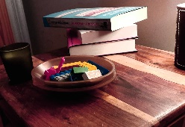What you’ll need:
A small selection of Lego bricks between 10 and 20 chunky bricks, you can choose colours, shapes.
A container to keep them in something with a lid to keep them together
Shallow tray for building in – a shoebox lid or the container lid.

LEGO Night In
We’re all having nights in at the moment, but maybe a screen free night could be just the thing!
You can plan some creations and challenges or just let the ideas flow and have fun!
If you are looking for inspiration, here’s some of our favourites:

- What can you build with 10 bricks? Set a target and go for the challenge!
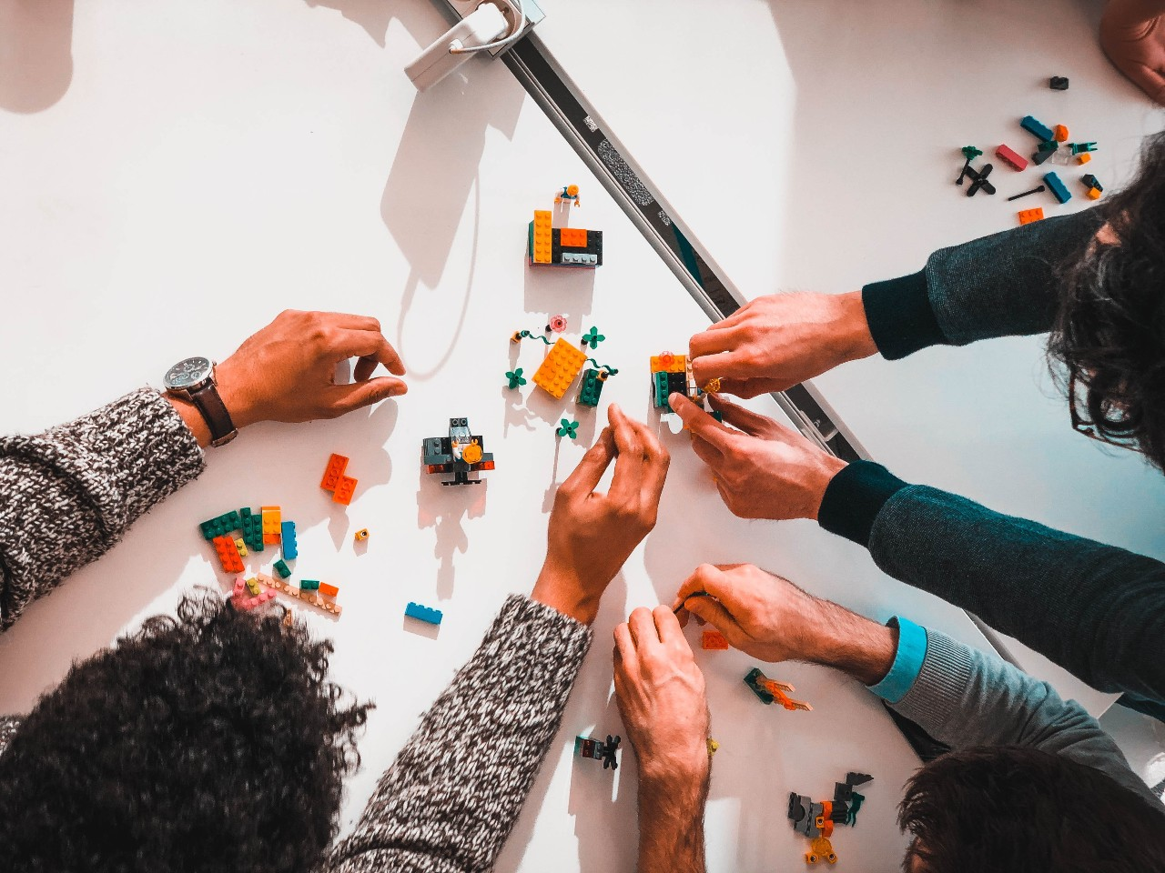

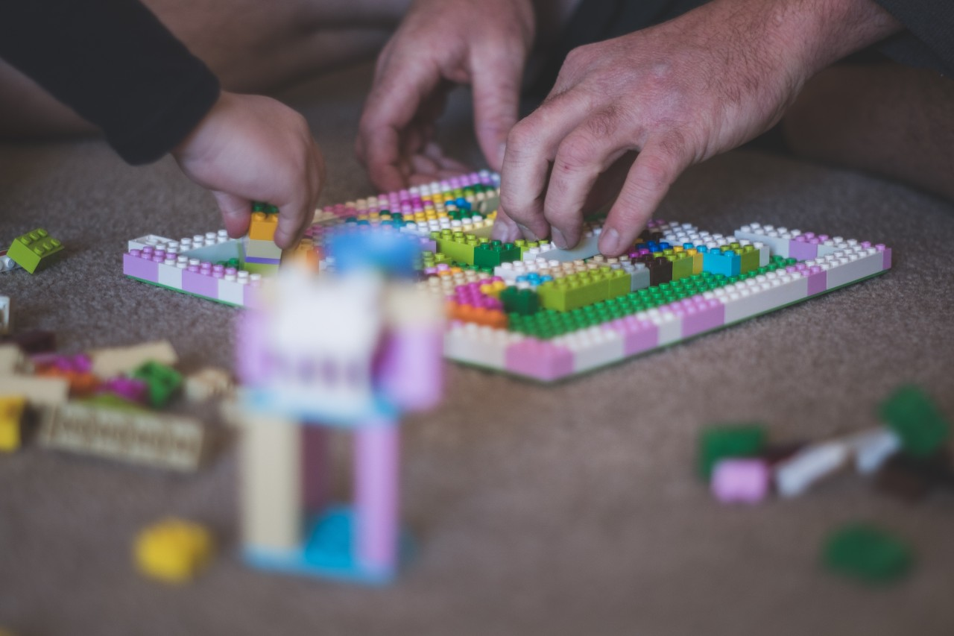

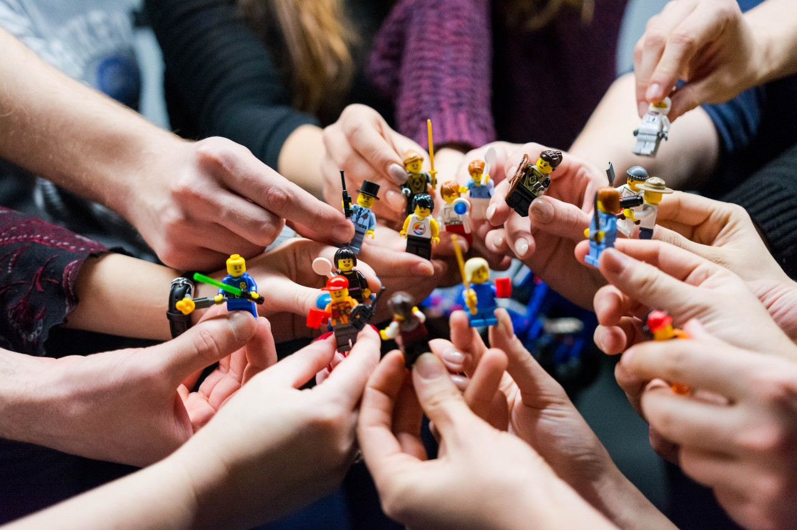

Inspiration from
Build yourself happy: the joy of LEGO play by Abbie Headon, Dorling Kindersley 2019

- The alphabet game: build something starting with the same letter A,B,C and so on. Can others guess what you’ve built?
- Build a model blindfold. Everyone builds the same thing? Do they even look the same?
- Guess the number of bricks in a pile or in a clear container
- Create a model with just one hand?
- Everyone get together and create a giant Lego pizza – with your favourite (or worst) toppings!

Connect. Build. Relax

