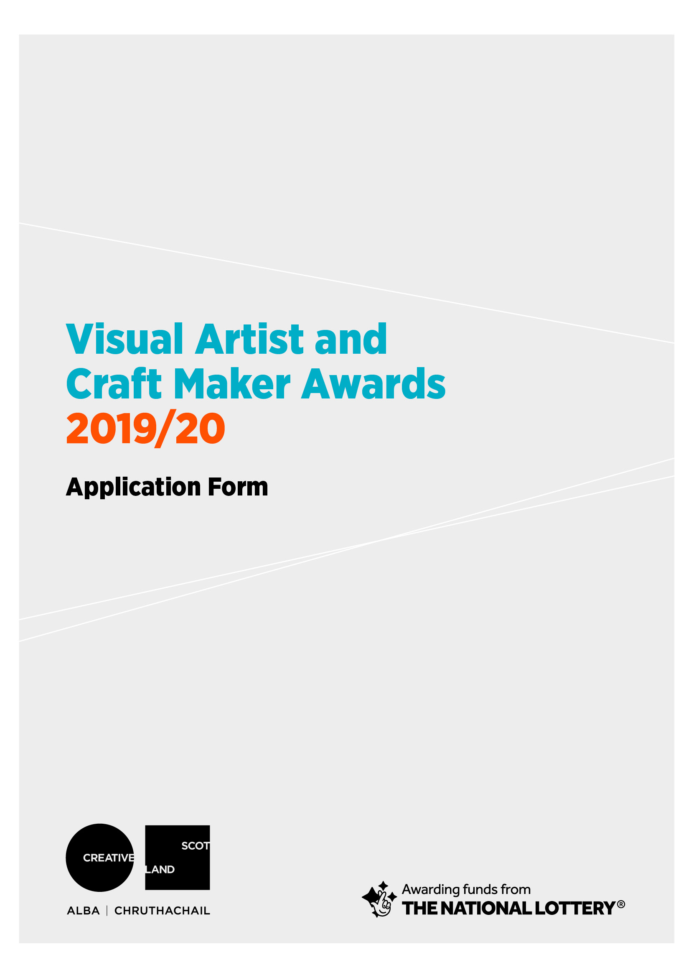

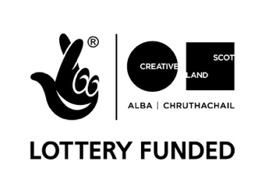

Visual Artist and Craft Maker Awards: area
in partnership with Creative Scotland
#VACMAScotland

1 APPLICATION DETAILS

Please ensure that you have read the Guidelines carefully before completing the form.

Name:

Address:

Postcode:

Contact Tel No(s):

e-mail:

website:

Start date:

Expected end date:

Amount of funding requested (up to a maximum of £1,500):

I am applying for the New Graduate / Emerging Artist Bursary of £500

Artform tick one box only
Visual Art
Craft

2 SUPPORTING INFORMATION

- Please submit a copy of your current artist CV (this helps us to understand what you have achieved so far in your practice, your training and track record)

- If you are applying for support for the development of work for an exhibition or for a residency, please provide a letter of support from the gallery / organisation which explains what they will be providing

- Please submit up to 6 high quality images or up to 3 minutes of film/sound files

- Please complete the Equalities Monitoring form
3 ABOUT YOU

Please tell us briefly about your practice. Max 250 words
What do you do and why do you do it?

What do you want funding for? Max 500 words

How will this develop your practice and what do you want to achieve in the long term?
Max 250 words

Is there any public element to the proposal? Max 200 words
e.g. an event, workshop, performance or exhibition. If yes tell us more about it.

Please give an outline and timetable (including dates) of the key stages and any preparation work you have done.

4 PREVIOUS APPLICATIONS

Have you had a VACMA, or Creative Scotland award before? If so, when?

If you have, please tell us how that support helped your practice, and whether this is a continuation of that project.

Priority in awards may go to those who have not previously been successful in the scheme. Applications will not be considered from previously successful applicants who have not yet submitted their End of Project Report.

5 PLACE

How long you have been resident in the area.
If you are not resident please say why you are applying to this scheme in this area.

6 BUDGET

Please provide a budget breakdown for your project, detailing the grant requested, your own financial contribution and any other sources of funding. Please indicate if these are cash or in-kind contributions and ensure in-kind is accounted for in both income and expenditure. If the cost exceeds £1,500, please include other sources of income and funding, showing which have been confirmed at time of application.

Expenditure - Breakdown of Estimated Project Costs

item | cost £ | Cash or in-kind
Total Cost of Project

Income – this figure should equal your expenditure above

 | £ | Confirmed  Cash or in-kind
Grant request from Award Scheme:
Own cash contribution:
Other sources of income (if applicable):
Total Estimated Income for Project

The focus of this fund is to support new opportunities for creative development and the change this can bring to your practice. Whilst we recognise that artists/makers time is crucial to creating new work or undertaking professional development activities we are not able to support day to day living costs or replace other income.

For the purposes of this application any time contribution is viewed as in-kind contribution and part of your professional practice. However, we would like to better understand the nature of this contribution so please provide the following information:

Number of days you intend to spend on this project:

7 ARTWORK SUBMISSION FORM

Name:

Image format:
(jpeg on CD, DVD, USB, etc)

Please enter details of the artwork submitted in support of your application. We cannot accept original artwork. Please read ‘How to Apply’ notes on guidance form.

We request that all supporting material is clearly labelled with your name and the title of works.

 | Images/ Work Title | Date | Size | Medium & Description
1
2
3
4
5
6

Please note that we can accept no responsibility for damage to or loss of material submitted in support of applications, although we will exercise all possible care in handling this material.

We are committed to protecting the rights and privacy of individuals in accordance with the Data Protection Act 2018. We need to process certain information about our staff, customers, and other individuals that we have dealings with for administrative purposes. We will also share the information provided with Creative Scotland as the funding partners to support evaluation, assessment and development. To comply with the Act, information collected about individuals must be used fairly, stored safely and securely and not disclosed to any third party unlawfully. Data Protection Act - The DPA 2018 sets out the framework for data protection law in the UK. It updates and replaces the Data Protection Act 1998, and came into effect on 25 May 2018. It sits alongside the GDPR, and tailors how the GDPR applies in the UK.

DECLARATION

I (print full name) _____________________________________ hereby apply for financial assistance towards the cost of undertaking the project described in this application. To the best of my knowledge and belief, the information given is correct.

Signature: ________________________________________________________________

Date:____________________________________________________________________

