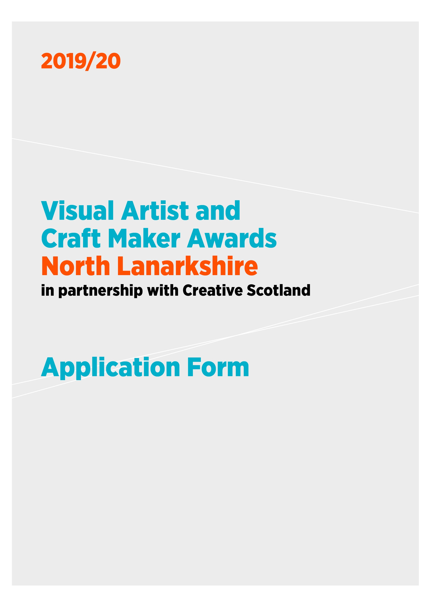

VACMA: North Lanarkshire is funded through a partnership between

Culture and LeisureNL Ltd, North Lanarkshire, and Creative Scotland
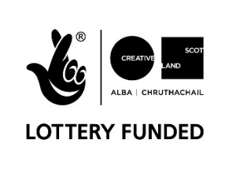

1 APPLICATION DETAILS

Please ensure that you have read the Guidelines carefully before completing the form.

Name:

Address:

Postcode:

Contact telephone number(s):

Email:

website:

Start date:

Expected end date:

Amount of funding requested (between £500-£1,500):

OR

I am applying for the New Graduate / Emerging Artist Bursary of £500

Artform tick one box only
Visual Art
Craft

2 SUPPORTING INFORMATION

- Please submit a copy of your current artist CV (this helps us to understand what you have achieved so far in your practice, your training and track record). You may also include your artist statement.

- If you are applying for support for the development of work for an exhibition or for a residency, please provide a letter of support from the gallery / organisation which explains what they will be providing

- Please submit up to 6 high quality images or up to 5 minutes of film/sound files

- Please complete the Equalities Monitoring form
3 ABOUT YOU

Please tell us briefly about your practice.
What do you do and why do you do it? Max 250 words

What do you want funding for? Max 500 words

How will this develop your practice and what do you want to achieve in the long term?
Max 250 words

Is there any public element to the proposal? e.g. an event, performance or exhibition. If yes, tell us more about it. Max 200 words

Please give an outline and timetable (including dates) of the key stages and any preparation work you have done.

4 PREVIOUS APPLICATIONS

Have you had a VACMA, or Creative Scotland award before? If so, when?

If you have, please tell us how that support helped your practice, and whether this is a continuation of that project.

Priority in awards may go to those who have not previously been successful in the scheme. Applications will not be considered from previously successful applicants who have not yet submitted their End of Project Report.

5 PLACE

How long you have been resident in the area?
If you are not resident please say why you are applying to this scheme in this area.

6 BUDGET

Please provide a budget breakdown for your project, detailing the grant requested, your own financial contribution and any other sources of funding. Please indicate if these are cash or in-kind contributions and ensure in-kind is accounted for in both income and expenditure. If the cost exceeds £1,500, please include other sources of income and funding, showing which have been confirmed at time of application.

Expenditure - Breakdown of Estimated Project Costs

item | cost £ | Cash or in-kind
Total Cost of Project

Income – this figure should equal your expenditure above

 | £ | Confirmed  Cash or in-kind
Grant request from Award Scheme:
Own cash contribution:
Other sources of income (if applicable):
Total Estimated Income for Project:

The focus of this fund is to support new opportunities for creative development and the change this can bring to your practice. Whilst we recognise that artists/makers time is crucial to creating new work or undertaking professional development activities we are not able to support day to day living costs or replace other income.

For the purposes of this application any time contribution is viewed as in-kind contribution and part of your professional practice. However, we would like to better understand the nature of this contribution so please provide the following information:

Number of days you intend to spend on this project:

7 ARTWORK SUBMISSION FORM

Name:

Image format:
(jpeg on CD, DVD, USB, etc)

Please enter details of the artwork submitted in support of your application. We cannot accept original artwork. Please read ‘How to Apply’ notes on the guidance form.

We request that all supporting material is clearly labelled with your name and the title of works.

 | Images/ Work Title | Date | Size | Medium and Description
1
2
3
4
5
6

Please note we cannot accept responsibility for damage to or loss of material submitted in support of applications, although we will exercise all possible care in handling this material.

We are committed to protecting the rights and privacy of individuals in accordance with the Data Protection Act 2018. We need to process certain information about our staff, customers, and other individuals that we have dealings with for administrative purposes. We will also share the information provided with Creative Scotland as the funding partners to support evaluation, assessment and development. To comply with the Act, information collected about individuals must be used fairly, stored safely and securely and not disclosed to any third party unlawfully. Data Protection Act - The DPA 2018 sets out the framework for data protection law in the UK. It updates and replaces the Data Protection Act 1998, and came into effect on 25 May 2018. It sits alongside the GDPR, and tailors how the GDPR applies in the UK.

DECLARATION

I (print full name) _____________________________________ hereby apply for financial assistance towards the cost of undertaking the project described in this application. To the best of my knowledge and belief, the information given is correct.

Signature:

Date:

Privacy notice for Community Arts Services, CultureNL

Who are we?
CultureNL is a trading name of Culture and Leisure NL Ltd. Culture and Leisure NL Ltd is a registered Scottish charity, charity number SCO 43891. We are an Arm’s Length External Organisation (ALEO) of North Lanarkshire Council.
How can you contact our Data Protection Officer?
To ask for advice or to make a request about your personal information contact us:
By mail: Records & Archives, North Lanarkshire Heritage Centre, High Road, Motherwell, ML1 3HU
By email: informationrequests@culturenl.co.uk

Why do we need your personal information and what do we do with it?
You are giving us your personal information to allow us to provide you with Community Arts Services. We also use your information to verify your identity where required, contact you by post, email, text or telephone and to maintain our records.
If you have opted in to marketing we will contact you in the way you have agreed and give you information about e.g. new or similar classes and activity or upcoming seasonal programmes.

Legal basis for using your information:
Processing your personal information is on the basis that it is necessary for the performance of a contract with you or to take steps to enter into a contract with you and that it is necessary for the performance of a task carried out in the public interest. We may also need to process more sensitive personal information about you in order to protect your vital interests in circumstances where we will not be able to seek your consent.
If you do not provide us with the information we have asked for then we will not be able to provide this service to you.
If you have opted in to marketing we will process your information based on consent.

Who do we share your information with?
We are legally obliged to safeguard public funds so we are required to verify and check your details internally for fraud prevention. We may share this information with other public bodies (and also receive information from these other bodies) for fraud checking purposes. We are also legally obliged to share certain data with other public bodies, such as HMRC and will do so where the law requires this. We will also generally comply with requests for specific information from other regulatory and law enforcement bodies where this is necessary and appropriate. Your information is analysed internally to help us improve our services. We also share your contact information (name, telephone and/or email) with the company that provides us with bulk text messaging/email messaging services. This service is used to give you information relating to our Community Arts Classes and Programme e.g. class cancellations. It is also used for marketing where you have asked us to send this to you.

How long do we keep your information for?
We only keep your personal information for the minimum period amount of time necessary. Sometimes this time period is set out in the law, but in most cases it is based on the business need. We maintain a records retention and disposal schedule which sets out how long we hold different types of information for. You can view this on our website at https://culturenl.co.uk/privacy-statement or you can request a hard copy from the contact address stated above.

Your rights under data protection law:
- Access to your information – you have the right to request a copy of the personal information that we hold about you.
- Correcting your information – we want to make sure that your personal information is accurate, complete and up to date. Therefore you may ask us to correct any personal information about you that you believe does not meet these standards.
- Deletion of your information – you have the right to ask us to delete personal information about you where:
- you think that we no longer need to hold the information for the purposes for which it was originally obtained
- you have a genuine objection to our use of your personal information – see Objecting to how we may use your information below
- our use of your personal information is contrary to law or our other legal obligations.
- we are using that information with your consent and you have withdrawn your consent – see Withdrawing consent to using your information below.
Objecting to how we may use your information:
You have the right at any time to tell us to stop using your personal information for direct marketing purposes.

Restricting how we may use your information:
In some cases, you may ask us to restrict how we use your personal information. This right might apply, for example, where we are checking the accuracy of personal information that we hold about you or we are assessing the objection you have made to our use of your information. This right might also apply if we no longer have a basis for using your personal information but you don't want us to delete the data. Where this right is realistically applied will mean that we may only use the relevant personal information with your consent, for legal claims or where there are other public interest grounds to do so.
Please contact us as stated above if you wish to exercise any of these rights.

Withdrawing consent to use your information – Where we use your personal information with your consent you may withdraw that consent at any time and we will stop using your personal information for the purpose(s) for which consent was given. Contact us on artsdevelopment@culturenl.co.uk for your details to be removed.
Information you have given us about other people:
If you have provided anyone else’s details on this form, please make sure that you have told them that you have given their information to CultureNL. We will only use this information to contact those people or you in the event of an emergency. If they want any more information on how we will use their information they can visit our web site at https://culturenl.co.uk/privacy-statement or email informationrequests@culturenl.co.uk.

Complaints:
We aim to directly resolve all complaints about how we handle personal information. However, you also have the right to lodge a complaint with the Information Commissioner's Office, who can be contacted by post at: Information Commissioner's Office, Wycliffe House, Water Lane, Wilmslow, Cheshire, SK9 5AF. Visit their website for more information at- https://ico.org.uk/concerns

More information:
For more details on how we process your personal information visit https://culturenl.co.uk/privacy-statement or contact us by telephone (01698 274589).

