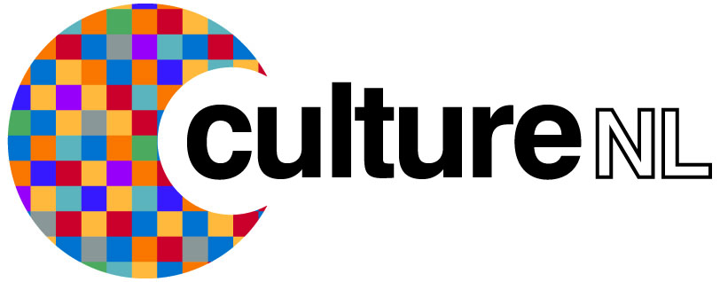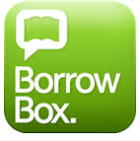

**Using Borrowbox via Computer**

The Borrowbox e-audio book and e-book service lets you download and listen to hundreds of e-audio books and e-books on your computer. To get started simply follow the instructions outlined below.

**Borrowing an e-audio book**

* Open an Internet browser and go to the North Lanarkshire Libraries Borrowbox page (<https://library.bolindadigital.com/northlanarkshire>).
* You can immediately search the catalogue by clicking on the search box in the top right hand side of the screen or simply click on an image of an e-audio book or e-book to go straight to that title.
* If you wish to hear some of the e-audio book before you download it you can click the

**Preview button** to listen to a short excerpt of the book.

* You can also recommend an item to a friend by clicking the **Tell a friend** button then

completing the online form.

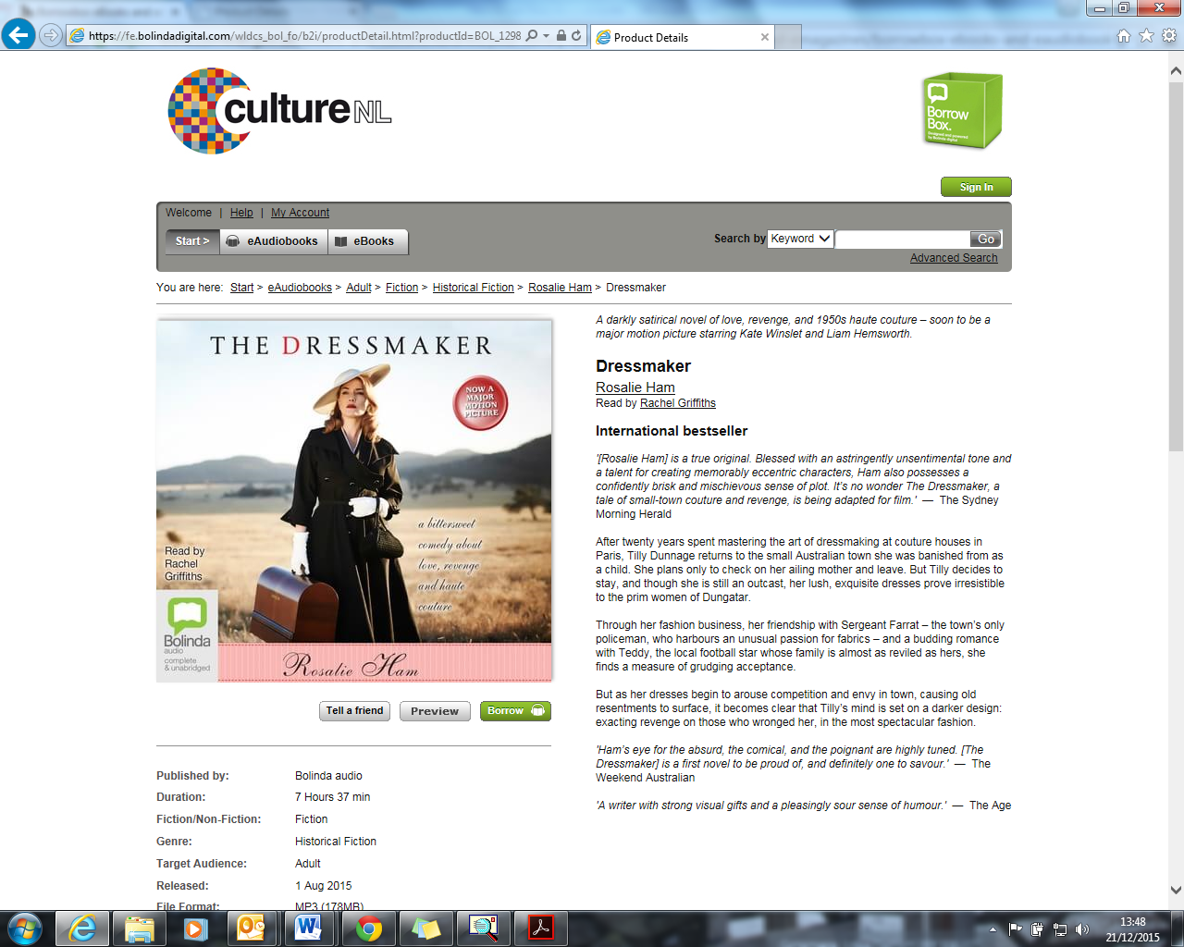

* To download the item click the **Borrow** button, this will take you to the login screen.

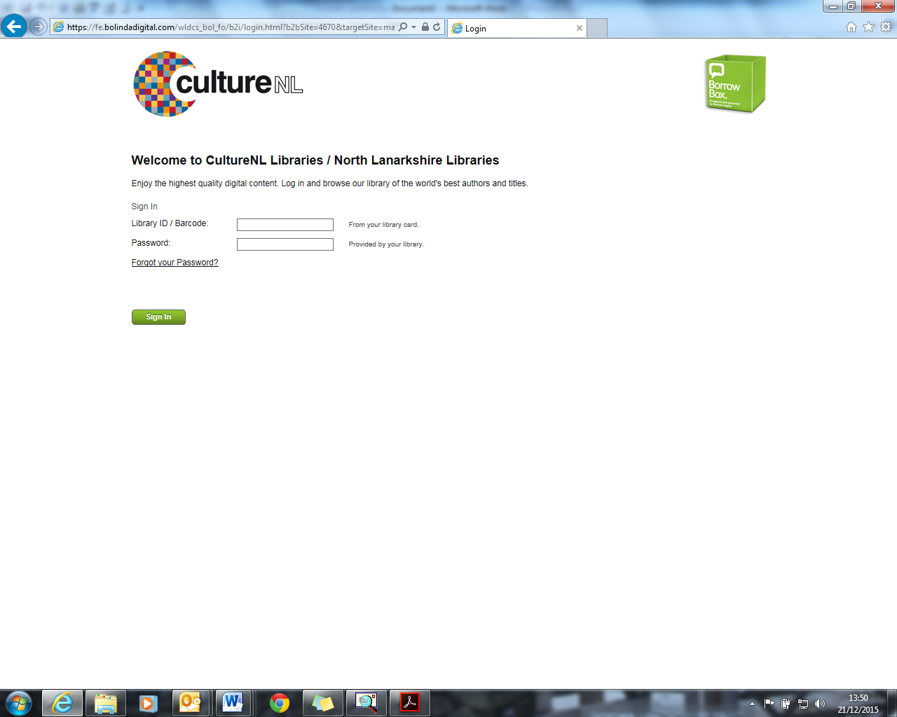

* Enter your library ID/Barcode (that’s the membership number of your library ticket) and a password/pin in the correct boxes
* If you don’t have a pin/password you can request one by contacting your local library or by sending an email to libraries@culturenl.co.uk quoting your library membership number, name, date of birth, and address, and we’ll get a password over to you as soon as we can.

If this is your first time using Borrowbox you will also be asked to provide a valid email address and screen name. You will also have to agree to the terms and conditions and indicate whether or not you would like to receive a library and Borrowbox newsletter.

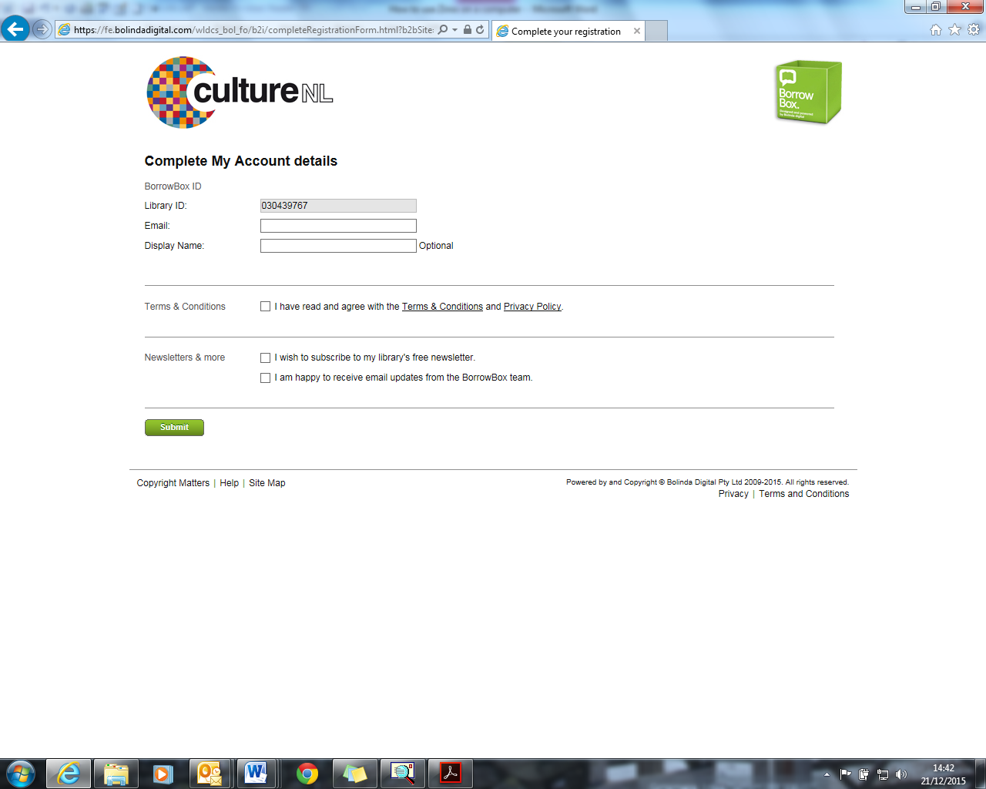

* Once you have supplied the necessary information (and have selected the title you wish to borrow) the following confirmation message will appear.

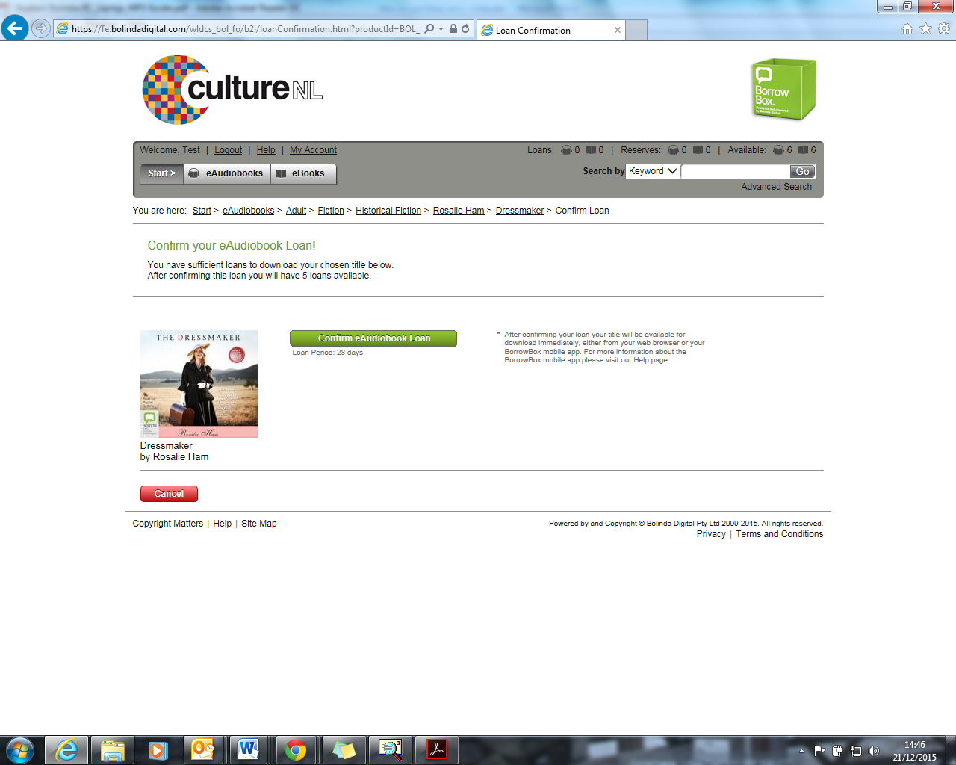

* Simply click on confirm e-audio book loan. You can now choose to download the complete e-audio book at once, or download it in sections.

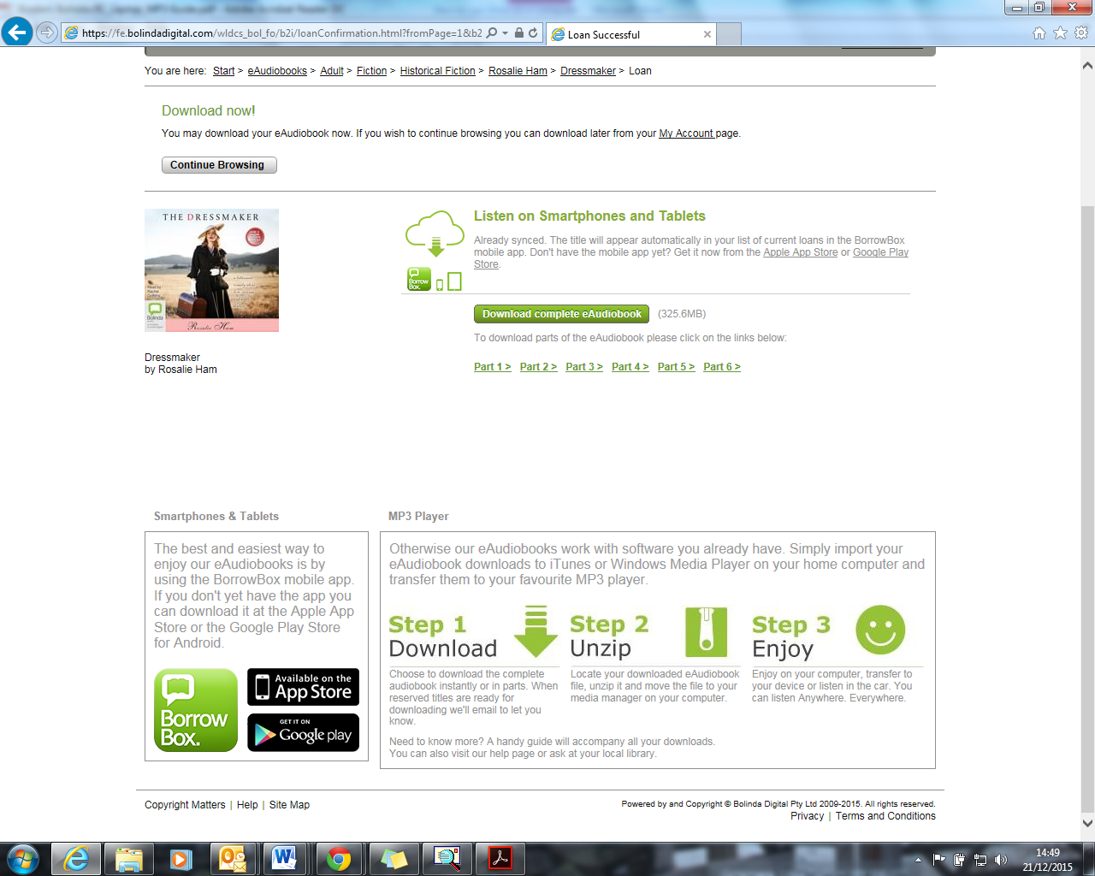

* It may take some time to download a complete e-audio book (depending on your internet

connection and the size of the file) so you may choose to download the e-audio book part

by part if you do not have time to wait.

* If you choose to download only the first part you can download any remaining parts

throughout your 28 day loan period by logging into your e-audio book account at any time

at the <https://library.bolindadigital.com/northlanarkshire> webpage.

* How downloading the e-audio book works depends on which internet browser, and which

version of each browser, you are using.

* Whichever way you decide to download the e-audio book a popup bar will appear at the bottom of the browser asking what action to take with the file, click Save As.



* The default download location varies depending on your browser/pc/laptop.

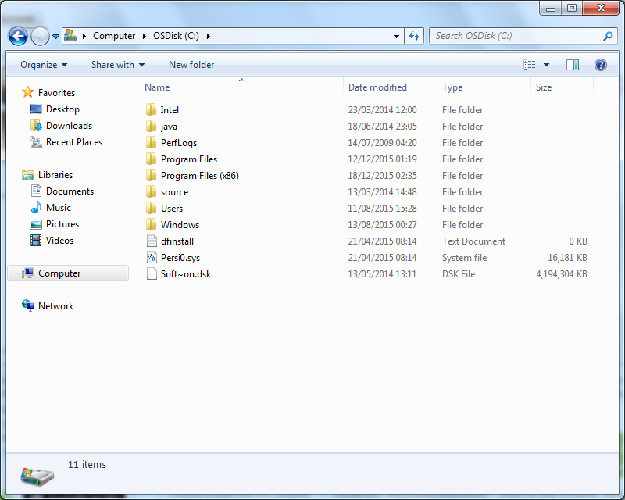

Select to save the .zip file

* The file you have downloaded is a compressed file and needs to be unzipped - to do so

right click on the file and select **Extract All… then click Extract.**



* You will now have two entries, one zip file and one ordinary file. Simply click on the ordinary file and it will open up in your default audio player (iPlayer, Windows player etc…).
* If you have any questions or queries please contact us on the following Freephone number 0800 9531010 or email us at logintolearn@culturenl.co.uk

**Borrowing an e-book**

* The borrowing process for e-books is the same as that for e-audio books until you get to the download stage. Once you have selected your e-book, completed the necessary login processes and confirmed you wish to borrow the e-book the following will appear on screen

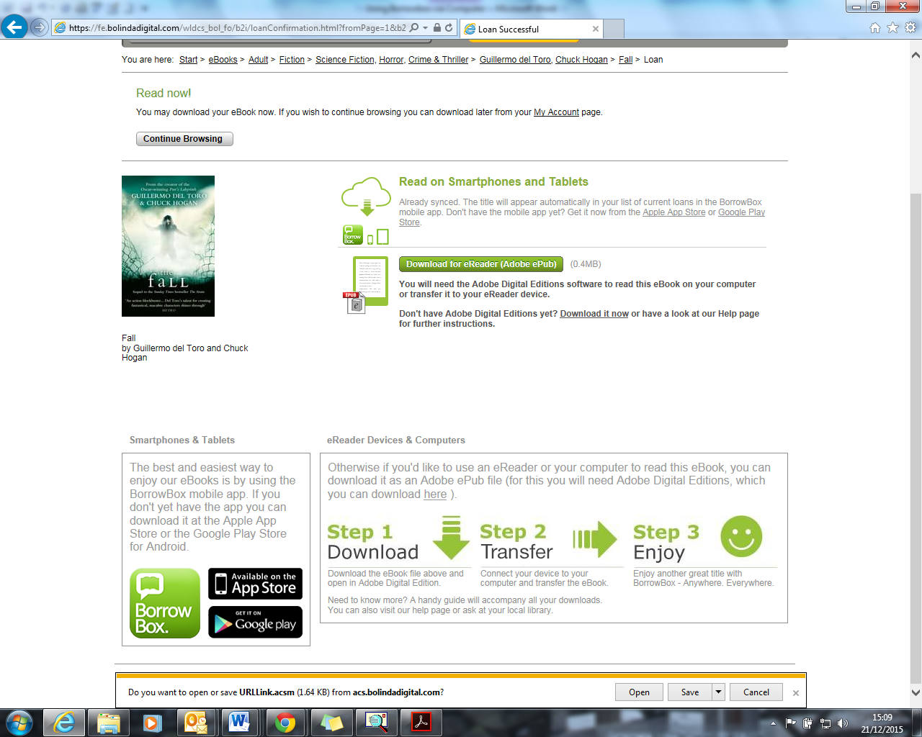

* To read your e-book you will need Adobe Digital Additions software installed on your computer. Simply follow the on-screen instructions for downloading Adobe Digital additions onto your computer. Once this has been completed and you have registered with Adobe you will be able to read the e-book on your computer.
* If you have any questions or queries please contact us on the following Freephone number 0800 9531010 or email us at [logintolearn@culturenl.co.uk](mailto:logintolearn@culturenl.co.uk).