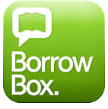
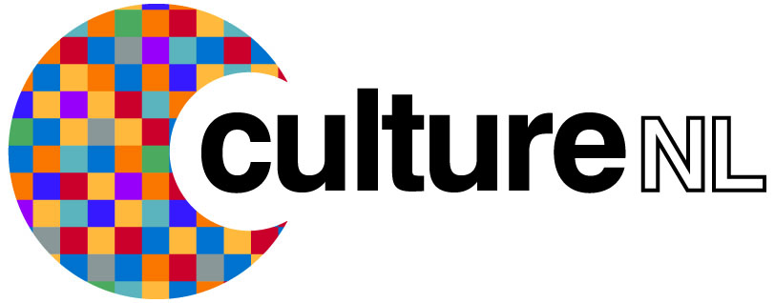

How to use the BorrowBox Apple App

The Borrow Box e-audio book and e-book service lets you download and listen to hundreds of e-audio books and e-books on your iPhone or iPad. To get started simply follow the instructions outlined below.

Getting started

- Download the Borrow Box app by going to the Apple Store and searching BorrowBox.

- Once the app is downloaded open it up.

- You will be asked to search for your library, type in either CultureNL Libraries or North Lanarkshire Libraries and press select.

- You will then be asked to type in your library membership number and your pin/password.

- If you don’t have a pin/password you can request one by contacting your local library or by sending an email to libraries@culturenl.co.uk quoting your library membership number, name, date of birth, and address, and we’ll get a password over to you as soon as we can.

- Next tap agree to the terms and conditions.

- You will be asked to provide an email contact and asked if you wish to receive a library and Borrow Box newsletter. We suggest you select these as you will then receive information about the latest titles we add to Borrow Box.

- Press done and you will be taken your account, showing available loans and any borrower history, you will also be able to view all our e-audio book and e-books.

- You will be given 6 e-audio books and 6 e-book loans, everything from selecting and borrowing to reading and renewing loans can now be done directly from your app.

Borrowing an e-audio book or e-book

- To view the e-audio books list click the e-audio icon at the bottom of the screen.

- To view the e-books list click the e-books icon at the bottom of the screen.

- To view all items of each type click the all releases link at the top of the relevant page. You can also use the Available button here to see only the titles that are available for loan.

- Tap on an item to view full item information. The preview feature lets you try before you borrow.

- You can search for a title by clicking on the magnifying glass icon at the bottom of the screen.

- Once you have selected your item click borrow and then confirm loan.

- E-audio books and e-books are both loaned for 28 days.

- Ebooks will download automatically.

- If you’ve borrowed an e-audio book either use the green down arrow at the bottom of the screen to download the whole book or tap the 3 dots on the top right hand side of the screen and select individual chapters to download.

- You can return an item at any time by clicking on the return button.

- If you have any questions or queries please contact us on the following Freephone number 0800 9531010 or email us at logintolearn@culturenl.co.uk

