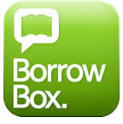
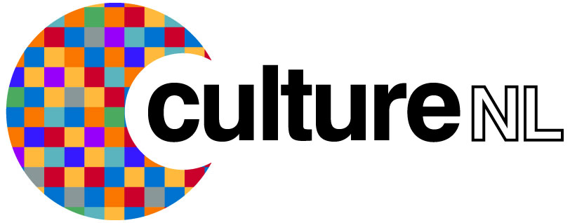

How to use the BorrowBox Android App

The Borrow Box e-audio book and e-book service lets you download and listen to hundreds of e-audio books and e-books on your smartphone or tablet. To get started simply follow the instructions outlined below.

Getting started

- Download the Borrow Box app by going to the Play Store and searching BorrowBox.

- Once the app is downloaded open it up.

- You will be asked to search for your library, type in either CultureNL Libraries or North Lanarkshire Libraries and press select.

- You will then be asked to type in your library membership number and your pin/password.

- If you don’t have a pin/password you can request one by contacting your local library or by sending an email to libraries@culturenl.co.uk quoting your library membership number, name, date of birth, and address, and we’ll get a password over to you as soon as we can.

- Next tap agree to the terms and conditions.

- You will be asked to provide an email contact and asked if you wish to receive a library and Borrow Box newsletter. We suggest you select these as you will then receive information about the latest titles we add to Borrow Box.

- Press done and you will be taken your account, showing available loans and any borrower history, you will also be able to view all our e-audio book and e-books.

- You will be given 6 e-audio books and 6 e-book loans, everything from selecting and borrowing to reading and renewing loans can now be done directly from your app.

Borrowing an e-audio book or e-book

- To view the e-audio books list click the e-audio icon at the top of the screen.

- To view the e-books list click the e-books icon at the top of the screen.

- You can also use the Available Only button at the bottom of the screen to see only the titles that are available for loan.

- Tap on an item to view full item information. The preview feature lets you try before you borrow.

- You can search for a title by clicking on the magnifying glass icon at the top of the screen.

- Once you have selected your item click borrow and then confirm loan.

- E-audio books and e-books are both loaned for 28 days.

- Ebooks will download automatically.

- If you’ve borrowed an e-audio book tap the 3 dots on the top right hand side of the screen and select download all or if you have limited time / internet connection click the green down arrow on the right of each chapter to download one chapter at a time.

- You can return an item at any time by clicking on the return button.

- If you have any questions or queries please contact us on the following Freephone number 0800 9531010 or email us at logintolearn@culturenl.co.uk

