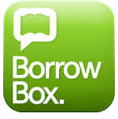
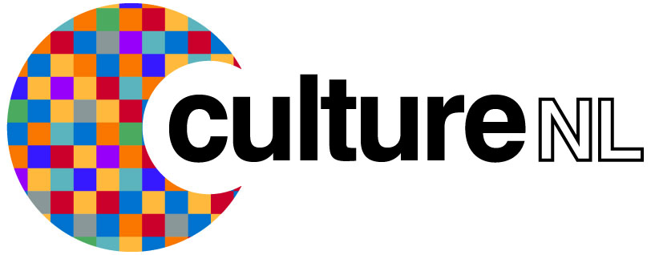

BorrowBox
Frequently Asked Questions

What is BorrowBox?
BorrowBox is an eAudiobooks and eBooks download service that CultureNL Libraries has subscribed to. The service consists of a website and the Borrowbox app for Apple, Android and Kindle Fire devices.

What is an eAudiobook?
An eAudiobook is the downloadable digital version of an audiobook (talking book) in MP3 format.

What is an eBook?
An eBook is the downloadable digital version of a book in ePub format.

What is a .zip file?
A .zip file is a file that has been compressed to reduce its size, making it quicker to
download.

How do I unzip eAudiobook downloads?
On a PC - Locate your downloaded eAudiobook folder, right click on the file and select Extract All, then follow the prompts to finish unzipping.
On a MAC - Locate your eAudiobook folder, then double click on the file to unzip it.
Some things to remember:
Your downloaded eAudiobook folder will be located where you have set your internet browser to download to (e.g. Downloads, Desktop, etc).
For Mac users, we recommend using Safari as your internet browser as unzipping occurs automatically. For those Mac users running the latest Mac OS, depending on your settings the
eAudiobook may automatically populate into iTunes.

Do I need software to download an eAudiobook?
No, to download an eAudiobook you only require a media manager or media device that is MP3 compatible.

What operating systems are supported?
All operating systems are supported, so long as you have an internet connection, compatible web browser and a media manager or device.

What internet browsers are supported?
This service will work on every browser, for example Internet Explorer, Firefox and
Chrome for Windows users and Safari, Firefox and Chrome for Mac users.
Why can I no longer download an eAudiobook that I have previously downloaded from My Account?
There is a limit on how often an eAudiobook can be downloaded to prevent excessive downloads. However, if for some reason you require additional downloads, please contact your library.

Where did the eAudiobook download to?
Your downloaded eAudiobook folder will be located where you have set your internet browser to download to. This is generally either a Downloads folder or your Desktop.

Do all eAudiobooks download at the same speed?
The speed of your download depends on your internet connection and the size of the eAudiobook. If you have limited data download or have selected a large eAudiobook to download, you may want to use the option of downloading in parts.

How do I play my eAudiobook?
In order to listen to your eAudiobook in a Media Manager, you need to ensure that you
have extracted the files (view above).
For Windows Media Player: open Windows Media Player then drag and drop the extracted folder into the main window of Windows Media Player. To find your eAudiobook, make sure you are in the Music Library of Windows Media Player, then click on Album and scroll down to the corresponding first letter of the title. Please note: if the title has a prefix like 'The', it will be sorted by the second word of the title.
For iTunes: open iTunes then drag and drop the extracted folder into your Music Library.

Why is there no option to borrow the title I want?
If you are unable to borrow a particular title it is already out on loan. You will be able to reserve it however.

Why can't I borrow or reserve any more titles?
CultureNL Libraries defines your loan settings. Once you have reached your quota of loans/reserves, you will need to wait until you have returned a loan.

Why can't I find the title I'm looking for?
Try using the quick search option to find the title. If that is not successful, try using the Advanced Search option and enter all known information about the title. If you still cannot find it, it may not be a title that we provide.

How do I change my account details?
After you log in, go to your My Account page, from there you can update your details by clicking the Edit Account Details button.

How do I delete my eAudiobooks from my computer once my loan period has finished?
Follow the following instructions to delete an eAudiobook from your computer once the loan period has expired:

On a PC: Locate your eAudiobook folder, then right click and select Delete from
the dropdown menu.
On a Portable Media Device: Connect your portable media device to your computer,
locate your eAudiobook folder, then right click on folder and select Delete from
the dropdown menu. Some devices may enable you to delete the audiobook file without connecting to a computer.
On a MAC Computer: Locate your eAudiobook folder and click on it, then hold down the
Apple key and press Delete.
In the Borrowbox app expired eAudiobooks and eBooks are deleted automatically.

Are the titles copyright protected?
Yes. Content from this service includes active security technology that allows identification of files.

If your question has not been answered above please contact us by emailing Logintolearn@culturenl.co.uk or phoning on 0800 9531010.

